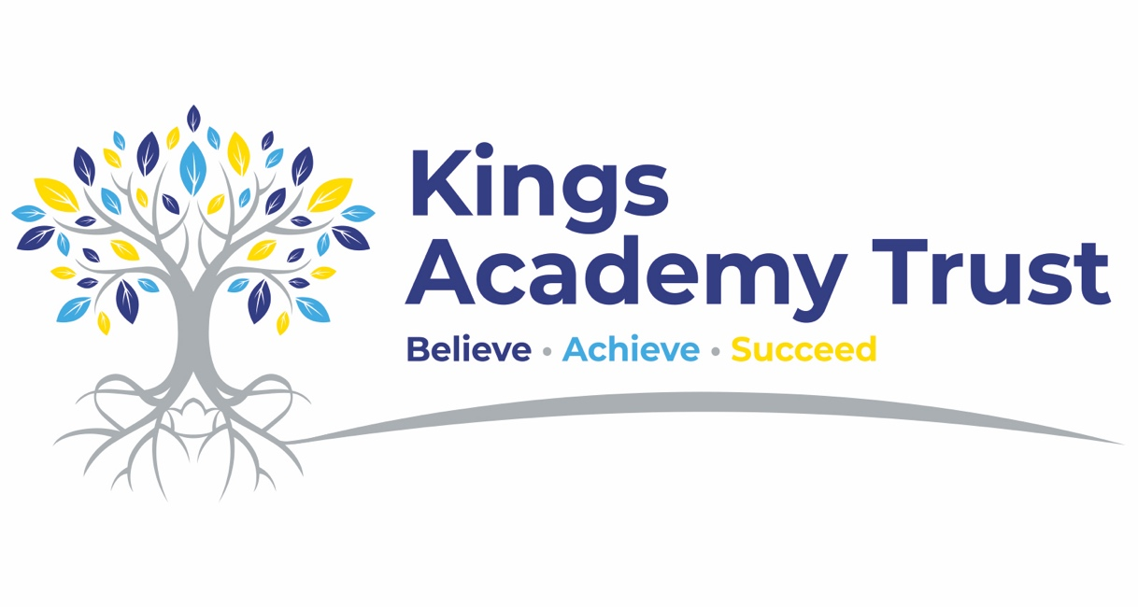

Use of artificial intelligence (AI) policy

Kings Academy Trust

Approved by: | February 2026 | Date: February 2025
Last reviewed on: | February 2026
Next review due by: | September 2026

Contents
Contents 2
1. Aims and scope 2
2. Legislation 3
3. Regulatory principles 3
4. Roles and responsibilities 4
5. Use of AI by staff across the trust, trustees and local governors 5
6. Educating pupils about AI 7
7. Use of AI by pupils 8
8. Formal assessments 8
9. Staff training 8
10. Breach of this policy 9
11. Referral to our child protection and safeguarding policy 9
12. Monitoring and transparency 10
12. Links with other policies 11

1. Aims and scope
At Kings Academy trust we understand the valuable potential that artificial intelligence (AI), including generative AI, holds for schools. For example, it can be used to enhance pedagogical methods, customise learning experiences and progress educational innovation.
We are also aware of the risks posed by AI, including data protection breaches, copyright issues, ethical complications, safeguarding and compliance with wider legal obligations.
Therefore, the aim of this policy is to establish guidelines for the ethical, secure and responsible use of AI technologies across our whole trust community.
This policy covers the use of AI tools by staff across the trust, trustees, local governors and pupils. This includes generative chatbots such as ChatGPT and Google Bard (please note, this list is not exhaustive).
This policy aims to:
- Support the use of AI to enhance teaching and learning
- Support staff across the trust to explore AI solutions to improve efficiency and reduce workload
- Prepare staff across the trust, trustees, local governors and pupils for a future in which AI technology will be an integral part
- Promote equity in education by using AI to address learning gaps and provide personalised support
- Ensure that AI technologies are used ethically and responsibly by all staff across the trust, trustees, local governors and pupils
- Protect the privacy and personal data of all staff across the trust, trustees, local governors and pupils in compliance with the UK GDPR
  - Definitions
This policy refers to both ‘open’ and ‘closed’ generative AI tools. These are defined as follows:
- Open generative AI tools are accessible and modifiable by anyone. They may store, share or learn from the information entered into them, including personal or sensitive information
- Closed generative AI tools are generally more secure, as external parties cannot access the data you input

2. Legislation
This policy reflects good practice guidelines / recommendations in the following publications:
- AI regulation white paper, published by the Department for Science, Innovation and Technology, and the Office for Artificial Intelligence
- Generative artificial intelligence (AI) and data protection in schools, published by the Department for Education (DfE)
This policy meets the requirements of the:
- UK General Data Protection Regulation (UK GDPR) – the EU GDPR was incorporated into UK legislation, with some amendments, by The Data Protection, Privacy and Electronic Communications (Amendments etc) (EU Exit) Regulations 2020
- Data Protection Act 2018 (DPA 2018)

3. Regulatory principles
As a trust, we follow the 5 principles set out in the AI regulation white paper.
Regulatory principle | WE WILL …
Safety, security and robustness | - Ensure that AI solutions are secure and safe for users and protect users’ data  - Ensure we can identify and rectify bias or error  - Anticipate threats such as hacking
Appropriate transparency and explainability | - Be transparent about our use of AI, and make sure we understand the suggestions it makes
Fairness | - Only use AI solutions that are ethically appropriate, equitable and free from prejudice – in particular, we will fully consider any bias relating to small groups and protected characteristics before using AI, monitor bias closely and correct problems where appropriate
Accountability and governance | - Ensure that the board of trustees, Local governing body and staff have clear roles and responsibilities in relation to the monitoring, evaluation, maintenance and use of AI
Contestability and redress | - Make sure that staff are empowered to correct and overrule AI suggestions – decisions should be made by the user of AI, not the technology  - Allow and respond appropriately to concerns and complaints where AI may have caused error resulting in adverse consequences or unfair treatment

4. Roles and responsibilities
4.0 Trust-level AI lead
Our generative AI trust lead is David Donnelly. They are responsible for the strategic oversight of AI use across the trust.
4.1 Board of trustees
The board of trustees will:
- Take overall responsibility for monitoring this policy and holding school leaders to account for its implementation in line with the trust’s AI strategy
- Review and update the AI policy as appropriate, and at least annually.
- Ensure school leaders are appropriately supported to make informed decisions regarding effective and ethical use of AI across the trust
- Sign off on approved uses of AI, or new AI tools, taking into account advice from the data protection officer (DPO) and data protection impact assessments
Trustees will adhere to the guidelines below to protect data when using generative AI tools themselves:
- Use only approved AI tools (see section 5)
- Seek advice from the data protection officer / IT / as appropriate
- Check whether they are using an open or closed generative AI tool
- Ensure there is no identifiable information included in what they put into open generative AI tools
- Acknowledge or reference the use of generative AI in their work
- Fact-check results to make sure the information is accurate
4.2 School leaders
School leaders will:
- Take responsibility for the day-to-day leadership and management of AI use in their school
- Liaise with the data protection officer (DPO) to ensure that the use of AI is in accordance with data protection legislation
- Ensure that the guidance set out in this policy is followed by all staff
- Ensure staff are appropriately trained in the effective use and potential risks of AI
- Make sure pupils are taught about the effective use and potential risks of AI
4.3 Trust data protection officer (DPO)
The trust-level data protection officer (DPO) is responsible for monitoring and advising on our compliance with data protection law, including in relation to the use of AI.
Our DPO is Satswana and is contactable via admin@satswana.com.
4.4 Safeguarding leads
Safeguarding leads are responsible for monitoring and advising on our compliance with safeguarding requirements including in relation to the use of AI, such as:
- Being aware of new and emerging safeguarding threats posed by AI
- Updating and delivering staff training on AI safeguarding threats
- Responding to safeguarding incidents in line with Keeping Children Safe in Education (KCSIE)
4.5 All staff
As part of our aim to reduce staff workload while improving outcomes for our pupils, we encourage staff to explore opportunities to meet these objectives through the use of approved AI tools. Any use of AI must follow the guidelines set out in this policy.
To protect data when using generative AI tools, staff must:
- Seek advice from the data protection officer / IT lead as appropriate
- Check whether they are using an open or closed generative AI tool
- Ensure there is no identifiable information included in what they put into open generative AI tools
- Acknowledge or reference the use of generative AI in their work
- Fact-check results to make sure the information is accurate
All staff play a role in ensuring that pupils understand the potential benefits and risks of using AI in their learning. All of our staff have a responsibility to guide pupils in critically evaluating AI-generated information and understanding its limitations.
4.6 Pupils
Pupils must:
- Follow the guidelines set out in section 7 of this policy (‘Use of AI by pupils’)

5. Use of AI by staff across the trust, trustees and local governors
5.1 Approved use of AI
At Kings Academy Trust we are committed to helping staff, trustees and local governors reduce their workload. Generative AI tools can make certain written tasks quicker and easier to complete, but cannot replace the judgement and knowledge of a human expert.
Whatever tools or resources are used to produce plans, policies or documents, the quality and content of the final document remains the professional responsibility of the person who produced it.
Any plans, policies or documents created using AI should be clearly attributed. Any member of staff, trustee or local governor using an AI-generated plan, policy or document should only share the AI-generated content with other members of staff, trustees or local governors for use if they are confident of the accuracy of the information, as the content remains the professional responsibility of the person who produced it.
Always consider whether AI is the right tool to use. Just because the trust has approved its use doesn’t mean it will always be appropriate.
The table below sets out the approved AI tools and the approved uses for each tool.

Approved tools | Approved uses
KeyGPT | Letter to parents/carers  Job descriptions and adverts  Interview questions
Co-Pilot | Information gathering/policy writing support
Chalkie AI | Lesson Planning
Arbor AI | Letter to parents/carers
Notebook LM (Google) | Research
Summary AI | Note Taking
ChatGPT | Research/Policy Writing

5.2 Process for approval
Staff are welcome to suggest new ways of using AI to improve pupil outcomes and reduce workload. They should contact their senior leader to discuss any ideas they may have with regards to using AI, so they can take the suggestions forward if they deem it to be a satisfactory new method of working.
David Donnelly is responsible for signing off on approved uses of AI, or new AI tools, taking into account advice from the DPO, and data protection impact assessments.
5.3 Data protection and privacy
To ensure that personal and sensitive data remains secure, no one will be permitted to enter such data into unauthorised generative AI tools or chatbots.
If personal and/or sensitive data is entered into an unauthorised generative AI tool, Kings Academy Trust will treat this as a data breach and will follow the personal data breach procedure outlined in our data protection policy. https://www.kingsacademytrust.org/documents/policies/data-protection-policy.pdf
Please also refer to section 10 of this policy.
5.4 Intellectual property
Most generative AI tools use inputs submitted by users to train and refine their models.
Pupils own the intellectual property (IP) rights to original content they create. This is likely to include anything that shows working out or is beyond multiple choice questions.
Kings Academy Trust will not allow or cause intellectual property, including pupils’ work, to be used to train generative AI models without appropriate consent or exemption to copyright.
Exemptions to copyright are limited – we will seek legal advice if we are unsure as to whether we are acting within the law.
5.5 Bias
We are aware that AI tools can perpetuate existing biases, particularly towards special characteristics including sex, race and disability. This means that critical thought must be applied to all outputs of authorised AI applications. This means fact and sense-checking the output before relying on it.
Kings Academy Trust will ensure we can identify and rectify bias or error by training staff in this area.
We will also regularly review our use of AI to identify and correct any biases that may arise.
If parents/carers or pupils have any concerns or complaints about potential unfair treatment or other negative outcomes as a consequence of AI use, these will be dealt with through our usual complaints procedure. https://www.kingsacademytrust.org/documents/policies/complaints-handling-policy.pdf
5.6 Raising concerns
We encourage staff to speak to their school leader in the first instance if they have any concerns about the potential use of AI, or the use of AI that may have resulted in errors that lead to adverse consequences or unfair treatment.
5.7 Ethical and responsible use
Kings Academy Trust will always:
- Use generative AI tools ethically and responsibly
- Remember the principles set out in our trust’s equality policy when using generative AI tools https://www.kingsacademytrust.org/documents/policies/equality-policy.pdf
- Consider whether the tool has real-time internet access, or access to information up to a certain point in time, as this may impact the accuracy of the output
- Fact and sense-check the output before relying on it
Staff members, trustees and local governors must not:
- Generate content to impersonate, bully or harass another person
- Generate explicit or offensive content
- Input offensive, discriminatory or inappropriate content as a prompt

6. Educating pupils about AI

Here at Kings Academy Trust we acknowledge that pupils benefit from a knowledge-rich curriculum that allows them to become well-informed users of technology and understand its impact on society. Strong foundational knowledge will ensure that pupils develop the right skills to make best use of generative AI.
- Creating and using digital content safely and responsibly
- The limitations, reliability and potential bias of generative AI
- How information on the internet is organised and ranked
- Online safety to protect against harmful or misleading content

7. Use of AI by pupils

Kings Academy Trust recognises that AI has many uses to help pupils learn.
- As a research tool to help them find out about new topics and ideas
- When specifically studying and discussing AI in schoolwork, for example in IT lessons or art homework about AI-generated images
All AI-generated content must be properly attributed and appropriate for the pupils’ age and educational needs.
AI may also lend itself to cheating and plagiarism. To mitigate this, pupils may not use AI tools:
- During assessments, including internal and external assessments, and coursework
- To write their homework or class assignments, where AI-generated text is presented as their own work
- To complete their homework, where AI is used to answer questions set and is presented as their own work (for example, maths calculations)
This list of AI misuse is not exhaustive.
Where AI tools have been used as a source of information, pupils should reference their use of AI. The reference must show the name of the AI source and the date the content was generated.
We consider any unattributed use of AI-generated text or imagery to be plagiarism and will follow our plagiarism procedures as set out in schools exams policies.
Pupils must consider what is ethical and appropriate in their use of AI and must not:
- Generate content to impersonate, bully or harass another person
- Generate explicit or offensive content
- Input offensive, discriminatory or inappropriate content as a prompt
- Pupils should be provided with training on the use of AI through the curriculum and online safety.

8. Formal assessments

Kings Academy Trust will continue to take reasonable steps where applicable to prevent malpractice involving the use of generative AI in assessments. See our trust exams / assessment policy for more details.
We will follow the latest guidance published by the Joint Council for Qualifications (JCQ) on AI use in assessments.

9. Staff training
Staff will be kept up to date with developments in AI, with continued CPD and updates in the availability of AI and new AI programmes available across the Trust. They will be able to develop and improve their practice on a regular basis with access to
- continuing professional development (CPD) opportunities on AI through the National College.
- training on new AI programmes
- changes in policy and updates on new developments will be shared with staff across the trust.

10. Breach of this policy
10.1 By staff
Breach of this policy by staff will be dealt with in line with the trust’s staff code of conduct.
Where disciplinary action is appropriate, it may be taken whether the breach occurs:
- During or outside of working hours
- On an individual’s own device or a school device
- At home, at school or from a remote working location
Staff members will be required to co-operate with any investigation into a suspected breach of this policy. This may involve providing the trust with access to:
- The generative AI application in question (whether or not it is one authorised by the trust)
- Any relevant passwords or login details
You must report any breach of this policy, either by you or by another member of staff, to your senior leader immediately.
10.2 By trustees or local governors
Trustees or local governors found in breach of this policy will be handled by the CET team following the appropriate steps and procedures.
10.3 By pupils
Any breach of this policy by a pupil will be dealt with in line with the trust’s behaviour policy https://www.kingsacademytrust.org/documents/policies/behaviour-and-anti-bullying-policy.pdf

11. Referral to our child protection and safeguarding policy
The school is aware that the use of generative AI may in some circumstances lead to safeguarding concerns including, but not limited to:
- Sexual grooming
- Sexual harassment
- Sexual extortion
- Child sexual abuse/exploitation material
- Harmful content
- Harmful advertisements and promotions
- Bullying
Where there are safeguarding concerns arising from the use of generative AI, a report must be made to the DSL immediately.
Any such incident will be dealt with according to the procedures set out in the school’s child protection and safeguarding policy and child protection referral process.

12. Monitoring and transparency
AI technology, and the benefits, risks and harms related to it, evolves and changes rapidly. Consequently, this policy is a live document that must be kept updated by the CET Team whenever there is a significant change to either AI use by the trust or the associated risks of AI usage.
This policy will also be regularly reviewed and updated to align with emerging best practices, technological advancements and changes in regulations.
The policy will be shared with the board of trustees at least annually.
All teaching staff are expected to read and follow this policy. Executive Headteachers/Headteachers/ Head of School are responsible for ensuring that the policy is followed.
David Donnelly will monitor the effectiveness of AI usage across the trust.
We will ensure we keep members of the trust community up to date on the use of AI technologies for educational purposes. As part of our regular surveys, feedback from pupils, parents/carers and staff will be considered in the ongoing evaluation and development of AI use across the schools in our trust

12. Links with other policies
This AI policy is linked to our:
- Data protection policy
- Child Protection Polcy
- Assessment policy
- Exams policy
- Homework policy
- Behaviour policy
- Staff code of conduct
- Marking and feedback policy
- ICT acceptable use policy
- Online safety policy
- Equality policy

