Pupil premium strategy statement

This statement details our school’s use of pupil premium funding to help improve the attainment of our disadvantaged pupils.

It outlines our pupil premium strategy, how we intend to spend the funding in this academic year and the effect that last year’s spending of pupil premium had within our school.

School overview
Detail | Data
School name | Oakwood Academy
Number of pupils in school | 353
Proportion (%) of pupil premium eligible pupils
Academic year/years that our current pupil premium strategy plan covers (3 year plans are recommended) | 2025/2026  2026/2027  2027/2028
Date this statement was published | December 2025
Date on which it will be reviewed
Statement authorised by | Lisa Southwood  Executive Head Teacher
Pupil premium lead | Jack Ellis and Catherine McLaughlin (Dec 2025)
Governor / Trustee lead | Joanne Mullineux
Funding overview
Detail | Amount
Pupil premium funding allocation this academic year | £146,600
Recovery premium funding allocation this academic year | £0
Pupil premium funding carried forward from previous years (enter £0 if not applicable) | £0.00
Total budget for this academic year | £146,600

Part A: Pupil premium strategy plan

Statement of intent
Our aim is to use pupil premium funding to help us achieve and sustain positive outcomes for our disadvantaged pupils. We acknowledge that socio-economic disadvantage adds complexity to the additional challenges our pupils face, as all of our pupils have an Education Health Care plan (EHCP). Although our data (please see Oakwood Academy website to see the latest KPI/Data) shows us that there is minimal variation of the outcomes for our PP students when compared to their peers we are interested in unpicking the potential academic difference our pupils may have had, if they were not further disadvantaged by their socio-economic status. Current research from the EEF which states pupils who are entitled to both free school meals (FSM) and in receipt of an EHCP are 27 months behind, in comparison to a pupil who is entitled to FSM without an EHCP showing an attainment gap of 19 months with their peers. This shows an eight-month difference, suggesting that the primary need to support is the socio-economic deprivation factors.
Despite this, we know that our pupils need additional enhanced support for their SEND needs, which mainstream education has not been able to offer. Many of our pupils are working vastly below age related expectations. Here is a further breakdown of our school context:
- IDACI score of 0.497. When further analysed Salford’s main areas of deprivation surround employment, health and disability, and education with 85% of other neighbourhoods across England being less deprived.
- In 2024, 69% of pupils were within the bottom 20% most deprived nationally, with 45% in the 1–10% decile alone.
- ACORN Data Analysis - ACORN data (2024) shows that 78% of pupils at Oakwood Academy are classified within the ‘Urban Adversity’ or ‘Financially Stretched’ categories — significantly above the LA average.
Further important data analysis of our Pupil Premium students shows:
- There are 10/19 students eligible for PP at Willows. This is 52.6%.
- There are 146/247 students eligible for PP in our main site. This is 59.1%
- There are 19/89 students eligible for PP at our 6th form provision. This is 21%.
Year 5 | Year 6 | Year 7 | Year 8 | Year 9 | Year 10 | Year 11
4 | 6 | 31 | 27 | 29 | 33 | 27

- We have 27 students who are classified as speaking an additional language at home (EAL). Of these 18 pupils are entitled to PP. This shows that 66% of our EAL pupils also have socio-economic factors which may hinder their progress.
- We have 53 students who identify as being from an ethnic minority. 56.6% of these are entitled to pupil premium.
- 10 of our pupil premium students are being supported at CIN/CP level. These are one of our most vulnerable sub groups within our PP cohort. 13 additional PP pupils receive support at an early help or youth services level.
- 4 of our PP students are from a Gypsy/Roma/Traveller (GRT) background.
- 42 of our pupil premium pupils have persistent absenteeism. 2 of these pupils are at home due to parent choice. 7 of these pupils are being educated by an alternative provision. 5 of these pupils have considerable medical needs which impact their attendance. This equates to 27.6% of PP pupils.

As such we offer a tiered support model which aims to:

- Provide a high quality and ambitious curriculum for all as we know that high quality teaching is the best possible way to close the attainment gap (source)
- Close the disadvantage gap
- Ensure all pupils can read fluently and with good understanding to enable them to access the breadth of the curriculum
- Develop wider strategies such as overcoming non-academic barriers to learning
- Supporting progression to further and higher education and careers in our local area.
- Reduce absence
- Work alongside wider agencies to offer enhanced pastoral packages for our most vulnerable students.
The visual below is taken from EEF advice.
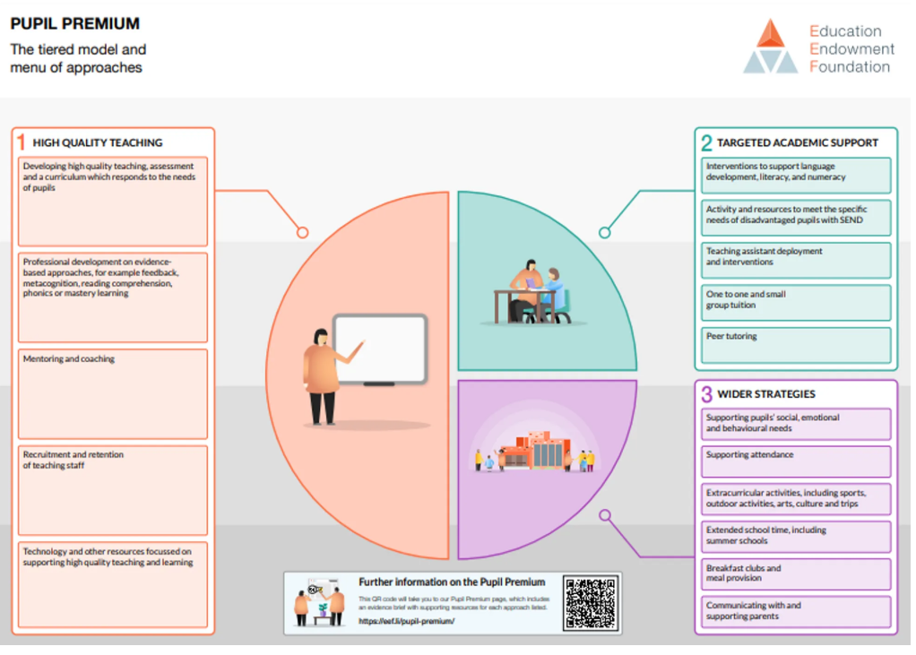
Our data (Please see Oakwood Academy website to see the latest KPI/Data) shows us that there is minimal variation of the outcomes for our PP students when compared to their peers.
At the heart of our approach is high-quality teaching focussed on areas that disadvantaged pupils require it most, targeted support based on robust diagnostic assessment of need, and helping pupils to access a broad and balanced curriculum.
Although our strategy is focused on the needs of disadvantaged pupils, it will benefit all pupils in our school where funding is spent on whole-school approaches, such as high-quality teaching. Implicit in the intended outcomes detailed below, is the intention that outcomes for disadvantaged pupils will be improved alongside progress for their less disadvantaged peers.
We will also provide disadvantaged pupils with support to develop independent life and social skills and continue to ensure that pupils are given the opportunity to take part in trips/visits and residential.
We ensure that all pupils regardless of PP status are offered thorough careers guidance and further and higher education guidance is available to all.
Our strategy is integral to wider school plans for education recovery, notably through engagement with school lead tuition for pupils that have been worst affected, including non-disadvantaged pupils.
Our strategy will be driven by the needs and strengths of each young person, based on formal and informal assessments, not assumptions or labels. This will help us to ensure that we offer them the relevant skills and experience they require to be prepared for adulthood.

Challenges
This details the key challenges to achievement that we have identified among our disadvantaged pupils.
Challenge number | Detail of challenge
1 | Basic skills – Owing to pupils SEND needs on entry, around 95% of pupils are assessed as working significantly below the peers in literacy and numeracy. Although our comparative data between PP and non PP shows minimal difference in attainment and progress we continue to acknowledge that supporting our pupils’ foundational knowledge is a key area for ongoing support.  Current data shows that academically, our PP pupils out-perform their non-PP counterparts in English with slightly more pupils working above target. Although previous trends have shown no real variation in academic attainment and progress in this subject. In maths, PP pupils are slightly below their non-PP counterparts in academic progress.
2 | Education and careers - Our assessments, observations and discussions with pupils show they may have uncertainty around their future paths, late diagnosis and lack of access to specialist primary education places, is linked to low self-esteem on entry and lower aspirations to the future. (Teacher led well-being assessments)
3 | Extra-curricular activities - Our assessments, observations and discussions with pupils show our most disadvantaged students do have the same access to wider life experiences in lines with their NPP peers. Social opportunities are very limited for many of our PP students outside of those offered by the school. Including access to clubs and community events and accessible transport. To evidence this, access to our own afterschool activities is limited with only 4 families who do not require transport attending. Only 16% of PP parents reported that their child attended any clubs outside of school. 50% of PP parents access social activities together less than twice a year. Parents reported the barriers were the expense and activities being too busy when visiting in school holidays or at weekends, which is over stimulating for neuro-divergent pupils.
4 | Parental engagement - Analysis of parents evening and annual review attendance shows us that we have less parental engagement from PP parents. Our wide catchment area and lack of transport compounds this difficulty. 41.7% of PP parents have barriers to attending school events, the most commonly reported barrier is transport.
5 | Persistent absence for the school is 27%, attendance for PP students is 97% inc auth. NPP is 98% inc auth. There is a slight difference in the percentage of pupils who are persistent absentees who are PP pupils, compared to those who are not.
6 | Additional vulnerabilities and/or barriers to learning – there is a higher proportion of PP pupils who speak English as an additional language, and those who identify as an ethnic minority compared to their peers. Although, not a disadvantage in some settings, and we acknowledge the value and enrichment speaking additional languages bring, our pupils have difficulties with communication and interaction, as well as other areas of SEND which can exacerbate some of the other socio-economic factors our pupils may face. Furthermore, there is an increase in our PP pupils accessing higher levels of social support (CP/CIN) than our non-PP pupils.

Intended outcomes
This explains the outcomes we are aiming for by the end of our current strategy plan, and how we will measure whether they have been achieved.
Intended outcome | Success criteria
Reduce the academic gap. | - All teachers across all curriculum areas use Quality Teach first teaching and have completed Oakwood T & L policy CPD.  - Curriculum continues to be adapted to provide pathways. This will make sure that our most complex SEND learners are being provided with the correctly pitched content at the right time for them. There must be solid foundations for our learners before new learning can be cemented.  - A dedicated timetable, with the necessary and relevant training to deliver targeted and meaningful interventions of identified pupils identified through the data.  - All staff delivering phonics have received new, or refresher training, in line with the phonics policy.  - All teachers, regardless of whether or not they deliver phonics have complete RWI training. This is to support students reading and spelling across all areas of the curriculum.  - CPD has been delivered to 100% teaching staff and HLTA’s in pedagogical approaches best suited to the needs of our learners.  - 2 Maths TAs have been trained in Catch-Up Numeracy.  - Highly trained staff deliver literacy and numeracy interventions.  - To support our below target pupil premium pupils with core subject tuition. We will employ a 1:1 tutor to work on targeted areas for 6 hours a week for those identified through our KPI.
To raise pupils’ aspirations. | - Introduction of ASDAN careers qualification at Year 10.  - Work experience for 100% of students at Year 10 and Year 11 at the Sixth form shop or cafe or the Oakwood Bistro.  - School supported visits to the colleges pupils may move on including visits to the Sixth form through the careers qualification.  - Sharing successes – inspirational previous students return and talk to pupils about their successes.  - Speakers on the assembly rota sharing details about different career pathways. Reformed speakers talking about their challenges and how they have overcome them appear on the assembly rota.
To provide all students with a range of out of school experiences that they may not otherwise have the opportunity to experience. | - An enhancement planner will be in place.  - A variety of curriculum and pastoral trips and visits mapped out across pupil’s time at Oakwood.  - A passport of experiences to be in place.
To provide students with more opportunities to develop outside interests and hobbies.  To provide more opportunities for our pupils to safely mix with their peers outside of the school day. | - To have in place an extended school co-ordinator.  - Continue delivering a range of after-school opportunities available to students.  - To have holiday clubs available at Easter and summer providing a range of social opportunities for pupils.  - To support attendance at clubs and holiday clubs by providing transport particularly for PP pupils.  - To increase PP attendance at school clubs by 25%
To improve parental engagement | - To have in place a staff member with responsibility for parental engagement.  - To provide more in the way of parent education eg. Phonics / early maths / safe social media use / protecting against grooming/ autism support strategies. To have invited parents into school a minimum of 8 times across an academic year.  - To encourage reluctant parents to develop a more positive relationship with school through offering more social events. Three social events organised through school per year.  - To support all parental engagement by providing alternative arrangements to access these events if needed e.g. school cloud  - To increase methods of communication for parents including an enhanced use of Evidence for Learning (EfL) as a pupil information sharing tool.
Persistent absence | - To offer an enhanced reward programme for improved attendance in our PP pupils  - Educate and engage parents/carers in understanding the importance of attendance to further support the improvement of persistent absence,  - To celebrate across all school platforms to pupils, staff and parents the impact of missing education, e.g Attendance of 95%, equals 10 days absent, that is 2 full school weeks, up to 50 lessons of learning missed  - Maintain persistent absence (PA) at or below 17%, ensuring it remains under the national averages, with regular monitoring and follow-up for pupils below 90% attendance.
Vulnerabilities | - Pupils at significant risk are identified early.  - 100% of pupils identified at risk have SMART room support in place  - Trust school counsellor in place to support identified pupils mental and emotional wellbeing  - Mental Health 1st Aid Champions at all sites  - Speakers, both to inspire pupils and warn them of dangers, appear regularly in the assembly cycle.  - Targeted pupil education around e-safety and the risks to all in the virtual world including being criminalised  - Parent education is provided.  - Targeted off-site support to support engagement.  - Full pastoral team to work across agencies to provide a multi-faceted model of supporting the child.  - EAL and ethnic minority champion to be employed across the school who will lead on promoting diversity and spoken languages for pupils and staff.  - Enhanced package of pastoral interventions which are monitored and assessed via MOATS and Arbor MIS. These will be reported on through the KPI.

Activity in this academic year
This details how we intend to spend our pupil premium (and recovery premium funding) this academic year to address the challenges listed above.

Teaching (for example, CPD, recruitment and retention)
Budgeted cost: £ 70,000
Activity | Evidence that supports this approach | Challenge number(s) addressed
Ensuring that all staff involved in the closing the skills gap has up to date and relevant training.  All staff across the school to be training in supporting the use of phonics across all curriculum areas. | Using a DfE approved phonics scheme (RWI) to support the catch up of our lowest attaining pupils throughout their school journey.  Teaching mathematics at key stage 3 - GOV.UK (www.gov.uk)There is strong evidence that teachers’ pedagogical and content knowledge within specific subjects has a significant impact on pupil outcomes:  Tuition targeted at specific needs and knowledge gaps can be an effective method to support low attaining pupils or those falling behind, both one-to-one:  One to one tuition | EEF (educationendowmentfoundation.org.uk)  And in small groups:  Small group tuition | Toolkit Strand | Education Endowment Foundation | EEF | 1,
Improving teaching though professional development and support.  T&L policy and associated training.  Numicon staff training.  IRIS reflections and action research based on T&L policy implementation. | Ofsted review of research  Developing teachers’ pedagogy through ongoing CPD  Ensuring an effective teacher is in front of every class and that every teacher is supported to keep improving.  Rosenshine's Principles in Action : Tom Sherrington Ofsted review of research | 1
Academic enhancement planner | https://www.gov.uk/government/news/englands-largest-outdoor-learning-project-reveals-children-more-motivated-to-learn-when-outside  https://educationendowmentfoundation.org.uk/education-evidence/teaching-learning-toolkit/outdoor-adventure-learning  EEF - Extracurricular activities, including sports, outdoor activities, arts, culture and trips | 2, 3, 4, 6
Introduction of ASDAN careers qualification at Year 10. | https://d2tic4wvo1iusb.cloudfront.net/production/documents  /guidance/Careers_review.pdf?v=1695030174 | 2,3,5,6
Ensuring all staff have the knowledge to support neurodiversity and SEMH needs. | Ensuring re-accreditation as an autism friendly school by the National Autistic Society.  https://www.autism.org.uk/what-we-do/autism-know-how/autism-accreditation  Receiving Emotionally Friendly Schools status.  https://www.emotionallyfriendly.co.uk/about-efs/theory-and-research-that-efs-is-based-on/ | 3, 5, 6

Targeted academic support (for example, tutoring, one-to-one support structured interventions)
Budgeted cost: £ 80,000
Activity | Evidence that supports this approach | Challenge number(s) addressed
HLTA and 3 TAs trained in Catch-up Maths to identify and support those learners with gaps in their knowledge. Weekly sessions and delivered to identified students.  2 TAs trained in RLI this is a a targeted, evidence-based approach to support the development of reading and language skills in children with Down syndrome. | Using a DfE approved phonics scheme to support the catch up of an identified cohort of pupils who have not made the expected progress due to the pandemic as per the KPI data.  Teaching mathematics at key stage 3 - GOV.UK (www.gov.uk)There is strong evidence that teachers’ pedagogical and content knowledge within specific subjects has a significant impact on pupil outcomes:  Tuition targeted at specific needs and knowledge gaps can be an effective method to support low attaining pupils or those falling behind, both one-to-one:  One to one tuition | EEF (educationendowmentfoundation.org.uk)  And in small groups:  Small group tuition | Toolkit Strand | Education Endowment Foundation | EEF  EEF – Teaching assistant interventions | 1, 2
After school booster sessions provided and open to all students who have been entered for GCSE in English and Maths. | Targeted academic support  EEF Parent engagement research shows that PP pupils are less likely to have a space to study at home. | 1, 2, 5, 6
Creation of intervention sessions on student timetables. To function on core skills: spelling, handwriting, guided reading, numeracy skills | Gov reading report | 1
Targeted 1:1 tutor to work with PP students below target in English and Maths | Targeted academic support: The evidence indicates that small group and one to one interventions can be a powerful tool for supporting these pupils when they are used carefully. | 1
ELKLAN trained staff | To increase our provision of ELKLAN trained staff across all sites, to work in a holistic manner to support the ever growing need for SALT and have embed techniques from our support staff and supporting our young people achieve their outcomes | 1

Wider strategies (for example, related to attendance, behaviour, wellbeing)
Budgeted cost: £ 82,779
Activity | Evidence that supports this approach | Challenge number(s) addressed
Purchase of the full Attendance Officer LA support package | To support and boost attendance using evidence based strategies and recording progress through the use of case studies and offering a holistic approach with wider agencies e.g. EWO  Education endowment foundation pupil premium support | 1, 3, 4, 5, 6
To employ a family support work, 1 day per week | Supporting Families Programme: Qualitative research: Family support worker: can providing lower-level parenting support, such as behaviour management and helping establish routines (for example, bedtime or school morning routines. • School attendance: Helping families establish routines, such as sleep hygiene, and exploring the reasons behind low school attendance. • Family functioning: Relationship building and conflict resolution between partners or parents and children. | 1, 3, 4, 5, 6
To ensure resources are available for all pupils to access all school opportunities | Attendance of offsite activities such as forest school, rock climbing, Duke of Edinburgh residential and reward trips.  Ensure resources are available to all pupils to access the full curriculum e.g PE Kit, Ingredients for Food tech, Uniform to ensure inclusion, fees covered for trips and visits to encourage life experiences outside of the classroom. | 1, 2, 4, 5, 6
Access to counselling service | Recruitment of our own trust counsellor to offer a full package of support to our pupils mental health and wellbeing including play therapy and bereavement counselling.  Enhanced counselling support package through THRIVE and EFS. | 1, 2, 5, 6,
Work experience for all students at Year 10 & Year 11 | https://d2tic4wvo1iusb.cloudfront.net/production/documents  /guidance/Careers_review.pdf?v=1695030174  Work experience and how it can help you: National Careers Service | 1, 2, 4, 6
Pastoral calendar for reward trips – creating for pupils an experience passport | https://www.gov.uk/government/news/englands-largest-outdoor-learning-project-reveals-children-more-motivated-to-learn-when-outside  https://educationendowmentfoundation.org.uk/education-evidence/teaching-learning-toolkit/outdoor-adventure-learning  EEF - Extracurricular activities, including sports, outdoor activities, arts, culture and trips | 1, 2, 3, 5, 6
Engage parents with less formal opportunities to develop relationships with the school and showcase our pupil's achievements | EEF – Parental engagement key findings  - Parental engagement has a positive impact on average of 4 months’ additional progress. It is crucial to consider how to engage with all parents to avoid widening attainment gaps.  - Providing practical strategies with tips, support, and resources to assist learning at home may be more beneficial to pupil outcomes than simply gifting a book to pupils or asking parents to provide generic help to their children  - Tailor school communication to create a positive dialogue about learning.  Family and parenting programmes: Rapid evidence assessment (Social Mobility Commission, 2023) | 1, 4, 5, 6,
Addressing barriers to engagement such as transport issues. |  | 1, 4, 5, 6,
Provide education to support parents with practical strategies to support learning. |  | 1, 4, 5, 6,
Provide education to support parents with protecting their child harm both online and in the real world. |  | 1, 4, 5, 6,
Extended School co-ordinator role | EEF – Parental engagement key findings  Evidence also suggests that disadvantaged pupils make less academic progress, and sometimes attainment levels even regress during the summer holidays, due to the level of formal and informal learning activities they do or do not participate in.  https://www.gov.uk/government/news/englands-largest-outdoor-learning-project-reveals-children-more-motivated-to-learn-when-outside  https://educationendowmentfoundation.org.uk/education-evidence/teaching-learning-toolkit/outdoor-adventure-learning  EEF - Extracurricular activities, including sports, outdoor activities, arts, culture and trips | 1, 2, 3,4,5,6
To increase the number after school clubs available in and out of term time |  | 1, 2, 3,4,5,6
To enable attendance at clubs by offering transport. |  | 1, 2, 3,4,5,6

Total budgeted cost: £ 232,779

Part B: Review of outcomes in the previous academic year

Pupil premium strategy outcomes
This details the impact that our pupil premium activity had on pupils in the 2023 to 2024 academic year.
Challenge 1 –
- Basic Skills – To reduce the academic gap
At Oakwood Academy, there is no noticeable difference in attainment between pupil premium (PP) and non-pupil premium (non-PP) pupils across all subjects. In some cases, PP pupils achieve higher outcomes than their non-PP peers. This is due to the staff's consistent efforts to provide equal access to education and opportunities, ensuring that all pupils are supported to reach their full potential.
This table below shows the progress in core subjects. PP pupils are working strongly across all core subjects and in some cases slightly outperforming non PP pupils AT (above target) and OT (on target). Science is an area to for action – this has been noted at senior leader level and actions have been taken to address this.
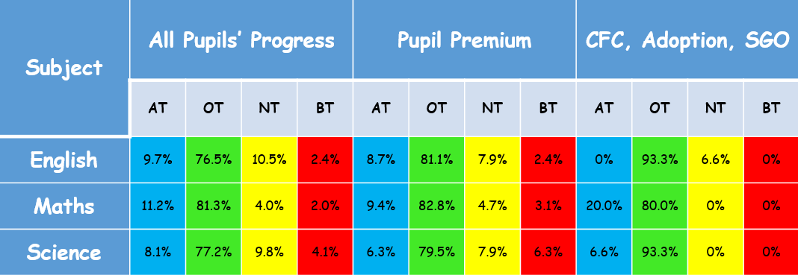

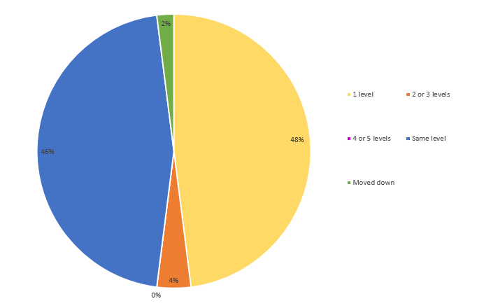
This commitment is further supported by a range of targeted intervention programs, such as which focuses on phonics. Recognising the importance of ensuring that all pupils leave school able to read independently, the academy has employed two HLTAs specifically to support the delivery of phonics. To maintain high standards, all staff participate in regular phonics training sessions. Additionally, a Head of Department TLR was introduced for Lisa Haselden, who oversees the planning and delivery of phonics across the entire school.

The chart above shows progress by pupil premium students in regards to their phonics level. 46% have stayed at the same level with 48% making one level of progress and 4% making 2 or more levels of progress.
Challenge 2
- Raise pupil aspirations
The second target of the pupil premium strategy is centred on raising pupil aspirations. To support this, Oakwood Academy has introduced the ASDAN careers qualification for Year 10 pupils, helping them develop essential skills for future education and employment. Year 10 and 11 pupils are also given the opportunity to visit Oakwood Sixth Form and Eccles College, broadening their understanding of post-16 options. Additionally, the assembly schedule now includes inspirational guest speakers to motivate pupils and encourage them to set ambitious goals for their future.
Another initiative supporting the "Raising Aspirations" target is the "Oakwood Bistro" project. This program offers targeted pupils the opportunity to develop skills in food technology. In the final week, parents are invited to sample the food, fostering a sense of achievement and community. The Bistro project is integrated with the SMART room to identify participants as part of a targeted intervention, ensuring it supports pupils who will benefit most from the experience. In the current academic year 2024/2025 the Bistro has targeted pupils in year 9.
Pupils Targeted |  | PP | NON PP
Autumn 2 | 16 | 4 | 12
Spring 1

Challenge 3 –
- To provide all with a range of experiences that they may not have had the opportunity to experience.
The third target focuses on providing all students with a range of out-of-school experiences they might not otherwise have access to. To support this, Oakwood Academy has implemented an enhancement planner that ensures every subject and department have trips/visits on the enhancement planner which are linked to the curriculum. Each subject has also outlined enhancements in their subject policies. A variety of curriculum and pastoral trips are carefully planned to enrich students' experiences throughout their time at Oakwood. Additionally, the school has introduced a "passport journey" using Evidence for Learning (EFL), enabling staff to document experiences electronically and share this journey with parents and carers.

In the academic year end July 2024 there were 30 entries onto the enhancement planner across 10 departments. (see below)

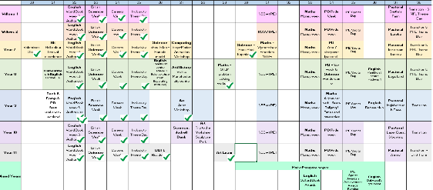

In academic year 24/25 there are 42 separate entries forecast for the enhancement planner. At time of review (May 2025) 64% of the enhancement planner has been completed.
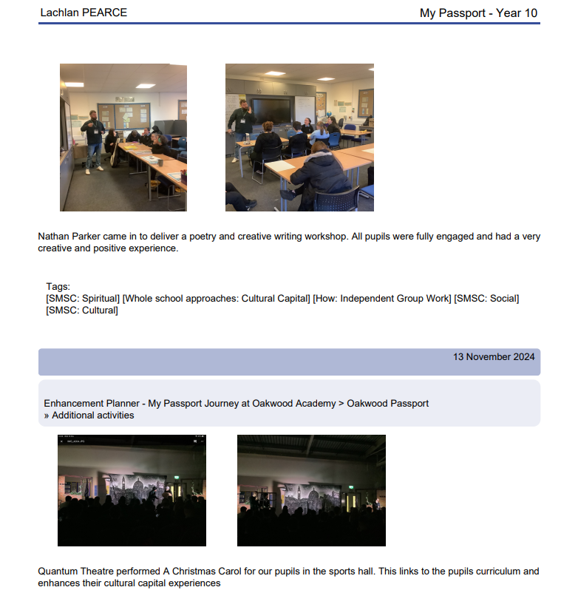
Evidence of ‘Passport Journey’ using Evidence for Learning.

Trips and Visits 21 - 22 | 346
Trips and Visits 22 - 23 | 627
Trips and visits 23-24 | 779
Trips and Visits 24-25 | No data available

We have greatly increased the number of trips and visits on offer to our students. The majority of these trips and visits are sport based. The enhancement offer has enhanced the number of trips that are now offered to pupils. Examples of offsite visits linked to enhancements that were provided are;

- Young voices choir
- Pastoral reward trips
- Church visits
- Yorkshire sculpture park – art project
- Art local photography project
- PE Competitions
- Careers trips – local 6th form

Additionally, we have a focus on in school visits such as author visits, scientists, problem solving workshops,

Challenge 4
- To provide students with more opportunities to develop outside interests and hobbies. To provide more opportunities for our pupils to mix safely with their peers outside of the school day.
The fourth target aims to provide students with more opportunities to develop outside interests and hobbies while encouraging safe interaction with peers beyond the school day. To support this, Oakwood Academy has expanded its after-school clubs from one evening per week to four, with partnerships developed with Salford Community Leisure. A new Tuesday club has also been introduced, offering a diverse range of activities such as music, craft, computers, and sports, catering to various interests and abilities.
Due to offering clubs over four nights (Monday to Thursday) we have seen an increase in pupil numbers accessing extra curricula clubs.
The table below shows the breakdown of club attendance and 5 of pupils who are PP is highlighted.
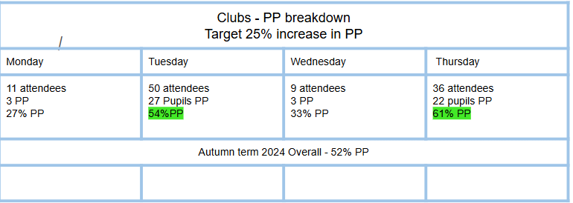
The table below shows the levels of club engagement compared against historic data which has been presented in previous PP reviews.

Attendance at ASC | Club numbers | PP | Non PP
2021/2022 | 36 | 48% | 52%
2022/2023 | 30 | 43% | 57%
2023/2024 | 75 | 49% | 51%
2024/2025 (Autumn1 ) | 106 | 62% | 38%

The increase in pupil premium (PP) pupils attending after-school clubs is directly linked to the diverse and extensive range of clubs. To further support attendance, we fund transportation for PP pupils, removing the primary barrier to participation. Without this critical support, attendance numbers would be significantly lower, highlighting the importance of addressing logistical challenges to ensure equal access for all students.
Challenge 5
- To improve parental engagement
The fifth target focuses on improving parental engagement. To support this, Oakwood Academy appointed J. Ellis in November 2023 to oversee parental engagement efforts. Key initiatives include the Oakwood Bistro, where parents join to celebrate their child’s achievements, and the Easter bingo event, which successfully engaged families and fostered community spirit. The school organises three open book evenings annually, along with a parents’ day held on an inset day to encourage maximum attendance. To further support participation, transport is provided on parents’ day, targeting areas with a high concentration of pupil premium families. Reluctant parents are engaged through Heads of Year during annual reviews and through the Pupil Inclusion Team, led by Ami Hilton, ensuring consistent support and communication. Additionally, Sarah Barrow has been employed across the trust in a ‘Family Support worker’ role.
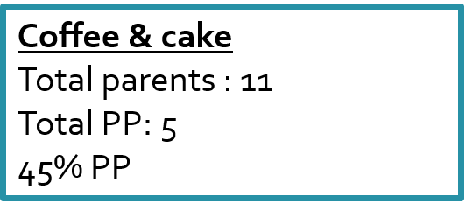
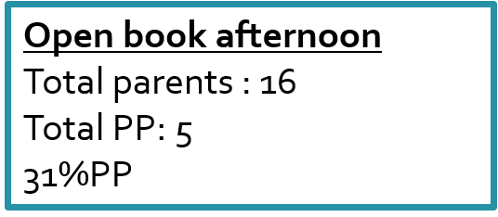

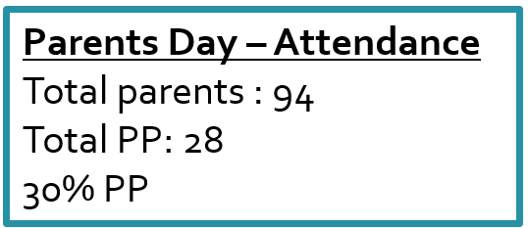

Challenge 6
- Persistent Absence
The sixth target focuses on reducing persistent absence. To achieve this, Oakwood Academy employs a range of strategies. Sarah Barrow works trust-wide to address persistent absence by building connections with families, while David Montoya, the trust counsellor, supports pupils most in need with strategies to improve attendance. Regular assemblies and rewards celebrate improved attendance, fostering a positive culture around being present at school.
Designated mental health champions, Nic Cass and Liz Cohen, collaborate with the inclusion team to provide tailored support. The school adopts a preventative whole-school approach that includes stage letters, Education Welfare Officer (EWO) involvement, termly attendance meetings, and daily attendance monitoring. Early interventions are offered via the EWO, Educational Psychologist, and individual action plans, with targeted support provided through external agencies like family help.

PA absence Autumn term

23-24 - 67 students
24-25 - 61 students (35 of these are pupil premium - 57%)
24-25 inc spring 89 85 pupils including 6th form and acer 38 of these pupils premium so 42%

PA absence Autumn term (not including DP/Chestnut)

23/24 | 60 students
24-25  24-25 spring term | 57 students  55 pupils 64 pupils including DP

SA Absence Autumn term

23-24 | 4 students
24-25  24- 25 spring term | 5 students  9 pupils. not inc DP

These students are for 24-25 academic year:

Laurence Lin | Moving placement and out of area
Makaila Sergent | SEMH
Shaniya Quigley | Placement
Emily Finn | Health reasons - multiple operations
Lucas S | SEMH
Jayden Bate | medical)
Abraar A | Placement
Maddison H Wainwright | SEMH
Samuel McMullen | still on data but not on role

Challenge 7 – Vulnerabilities
Oakwood Academy is committed to addressing vulnerabilities and protecting pupils from harm through a range of initiatives. Assemblies cover critical topics such as knife crime, gang involvement, fire safety, mental health, and racism, while partnerships with external providers ensure consistent and impactful workshops.
E-safety education is embedded into the curriculum for all pupils, with specific sessions highlighted in the enhancement planner. Parent-focused interventions on E-safety further reinforce these efforts. The Inclusion Team and SMART room deliver targeted support through programs like Love Rocks and counselling sessions, ensuring pupils are equipped to navigate potential risks.
Additionally, Oakwood engages young people at risk of disengaging from education by providing access to alternative provision. This tailored support aims to re-engage these pupils, helping them remain connected to their education and personal development.
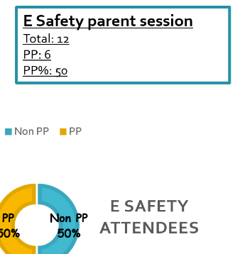
Attendance at Parental E Safety session is low taking into account pupil numbers but this is consistent with other parental events ran. Potential to film/zoom next session to reach more parents.

Phonics Parents session

Externally provided programmes
Please include the names of any non-DfE programmes that you purchased in the previous academic year. This will help the Department for Education identify which ones are popular in England
Programme | Provider
Evidence for Learning | Evidence for Learning
Read Write Inc | Read Write Inc Ruth Miskin
Catch up Maths | Catch up Maths
RLI | RLI
Love Rocks | Barnados

